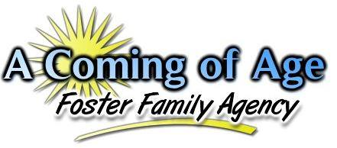
“Facing the challenges of daily life each and every day......forever struggling, forever maturing, working hard, to one day say, ‘I did it! I made it! I have finally come of age!’"
Intake Statistics for February 2019

During the month of February, our agency saw no major change in the total number of children referred to our agency. It was however, noticed that children between the ages of 15-17 years of age were referred the most during this particular month and that children between the ages of 12-17 years of age far exceeded the number of children referred in comparison to all other age groups. still referred in the greatest number to our agency this month, followed closely by children 15-17 years of age.
During this particular month, there were a total of 187 youth referred to the agency from both Riverside and San Bernardino Counties which are the only two counties that we have a contract with at this time.

The numbers identified in parenthesis represent the total number of actual calls received for that particular age group. Thus, there were a total of 25 calls for children 0-4 years of age during this particular month.

A breakdown of the various ethnicities of those children being referred to placement is identified below.

During the month of February, there were more Caucasan and African American children referred for placement as compared to other ethnic backgrounds of children. During this particular month, it was noticed that Hispanic children were not in the majority of those children referred to the agency.
When considering the issue of gender, the chart below provides a general overview for this month as to what the gender breakdown looked like this month.

This month saw a slight decrease in both the number of males and females that were referred to the agency as compared to the previous month. This month again saw more males referred to the agency than females which has been a consistent pattern for several months of this year. There were no transgendered youth referred to the agency during the month of February, 2019. There continues to be only one transgenered youth placed in our agency at this time.
One final observation to consider is the differences in the languages spoken by those youths who are being referred to our agency for placements. To consider this, the agency looked at the total number of youth who were referred for placement in the month and identified which youth were classified by the County as English only speakers, Spanish only speakers, Bilingual, or in some cases “Unknown” due to the County not stating a language spoken by the child. The graph below provided the results.

During the month of February, there was only 1 Spanish only speaking child referred to placement. All of the children referred to placement were English speaking only or binlingual speaking children. For clarification, only 1 child was identified as bilingual and thus 185 children were English only speaking. In regards to infants, the County will consider the spoken language of the parents to identify what language they speak. This information is used to calculate the language spoken by infants as well. Resource Parents or applicants who are Spanish only speakers need to understand this as placements take considerably longer if the primary caretaker only speaks Spanish as CPS will want to know that the child and caretaker can communicate with one another.

