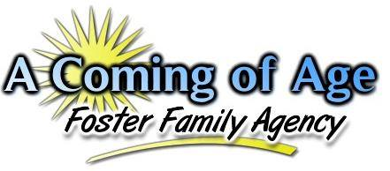
“Facing the challenges of daily life each and every day......forever struggling, forever maturing, working hard, to one day say, ‘I did it! I made it! I have finally come of age!’"
Intake Statistics for June 2018

During the month of June, our agency saw a slight increase in all ages of children referred to our agency with the greatest increase in those youth ages 12-14 who were referred to our agency for placement. However, there were still more children ages 0-4 who were referred to the agency over all other age ranges. This only goes to demonstrate that young children continue to enter into foster care in larger numbers, but other age children still need loving families to care for them and make sure that their needs are met. During this particular month, there were a total of 190 youth referred to the agency from both Riverside and San Bernardino Counties.

The numbers identified in parenthesis represent the total number of actual calls received for that particular age group. Thus, there were a total of 53 calls for children 0-4 years of age during this particular month.

A breakdown of the various ethnicities of those children being referred to placement is identified below.

During the month of June, there were more Hispanic children referred to placement as compared to other ethnic backgrounds of children. During this particular year thus far, we have seen where African American, Hispanic and Caucasian children have all tended to be the ethnicities that were referred the most in each particular month of this year thus far. It is typical to see Hispanic children being the ethnic backgrounds of children being placed the most followed closely by Caucasian and African-American children.

When considering the issue of gender, the chart below provides a general overview for this month as to what the gender breakdown looked like this month.

This month saw a significant increase in the number of males that were referred to the agency as compared to the previous month. Traditionally, it has been noticed that females tend to be referred in higher numbers, however this will continue to be monitored closely each month as the last couple of months have seen an exact opposite where males have been referred in much larger numbers than females. This month also saw no transgender youth referred to the agency. There does continue to be one trans-youth placed in our agency at this time.
One final observation to consider is the differences in the languages spoken by those youths who are being referred to our agency for placements. To consider this, the agency looked at the total number of youth who were referred for placement in the month and identified which youth were classified by the County as English only speakers, Spanish only speakers, Bilingual, or in some cases “Unknown” due to the County not stating a language spoken by the child. The graph below provided the results.

During the month of June, there was only one Spanish only speaking children referred to placement. All of the other children referred to placement were English speaking or identified as unknown due to the County not specifying a particular language spoken by the child. In regards to infants, the County will consider the spoken language of the parents to identify what language they speak. This information is used to calculate the language spoken by infants as well. Resource Parents or applicants who are Spanish only speakers need to understand this as placements June take considerably much longer if the primary caretaker only speaks Spanish as CPS will want to know that the child and caretaker can communicate with one another.

