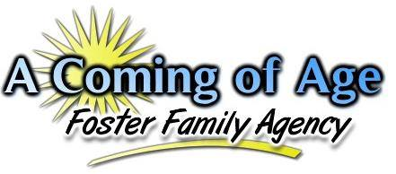
“Facing the challenges of daily life each and every day......forever struggling, forever maturing, working hard, to one day say, ‘I did it! I made it! I have finally come of age!’"
Intake Statistics for November 2018

During the month of November, our agency again saw increases in the number of children referred to our agency. This was due to the fact that all intake and social work staff were notified of the importance of keeping accurate statistics. Children between the ages of 0-4 years of age were still referred in large numbers to our agency this month, however it was observed that children between the ages of 12-14 were seen as the largest age group being referred this month.
During this particular month, there were a total of 244 youth referred to the agency from both Riverside and San Bernardino Counties which are the only two counties that we have a contract with at this time.

The numbers identified in parenthesis represent the total number of actual calls received for that particular age group. Thus, there were a total of 57 calls for children 0-4 years of age during this particular month.

A breakdown of the various ethnicities of those children being referred to placement is identified below.

During the month of November, there were more Caucasian children referred for placement as compared to other ethnic backgrounds of children. During this particular year thus far, there have been other months were Caucasian children were referred in the majority, however it is usually noticed that Hispanic children tend to be seen in the majority as being referred to placement with our agency.
When considering the issue of gender, the chart below provides a general overview for this month as to what the gender breakdown looked like this month.

This month saw an increase in both the number of males and females that were referred to the agency as compared to the previous month. This month again saw more males referred to the agency than females. This month also saw one transgender youth referred to the agency. There continues to be only one transgenered youth placed in our agency at this time.
One final observation to consider is the differences in the languages spoken by those youths who are being referred to our agency for placements. To consider this, the agency looked at the total number of youth who were referred for placement in the month and identified which youth were classified by the County as English only speakers, Spanish only speakers, Bilingual, or in some cases “Unknown” due to the County not stating a language spoken by the child. The graph below provided the results.

During the month of November, there were only 3 Spanish only speaking children referred to placement. All of the children referred to placement were English speaking only or binlingual speaking children. For clarification only 11 children were identified as bilingual and thus 230 children were English only speaking. In regards to infants, the County will consider the spoken language of the parents to identify what language they speak. This information is used to calculate the language spoken by infants as well. Resource Parents or applicants who are Spanish only speakers need to understand this as placements take considerably longer if the primary caretaker only speaks Spanish as CPS will want to know that the child and caretaker can communicate with one another.

