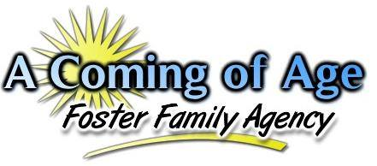
“Facing the challenges of daily life each and every day......forever struggling, forever maturing, working hard, to one day say, ‘I did it! I made it! I have finally come of age!’"
Intake Statistics for September 2018

During the month of September, our agency saw a very significant decrease in the total number of children referred to our agency as compared to the previous month. It is believed that thiswas due to tracking errors on the part of the Intake Department in that not all placement calls referred to the agency were actually tracked due to after hours placements not being fully inputted into the system. Regardless, there was consistency with regards to the overall statistics that were observed. Children between the ages of 0-4 years of age were still observed to be referred to the agency in regards to the largest age group of children. This has been consistent throughout the year.
During this particular month, there were a total of 185 youth referred to the agency from both Riverside and San Bernardino Counties which are the only two counties that we have a contract with at this time.

The numbers identified in parenthesis represent the total number of actual calls received for that particular age group. Thus, there were a total of 50 calls for children 0-4 years of age during this particular month.

A breakdown of the various ethnicities of those children being referred to placement is identified below.

During the month of September, there were more Hispanic children referred to placement as compared to other ethnic backgrounds of children. During this particular year thus far, we have seen individual months where African American, Hispanic and Caucasian children have all tended to be the ethnicities that were referred the most in each particular month of this year thus far. However, Hispanic children are typically the ethnic class of children who tend to be referred to the agency the most during the year followed closely by Caucasian and African-American children.

When considering the issue of gender, the chart below provides a general overview for this month as to what the gender breakdown looked like this month.

This month saw a decrease in both the number of males and females that were referred to the agency as compared to the previous month. This month did however see more males referred to the agency than females. This month also saw one transgender youth referred to the agency. There does continue to be one transgenered youth placed in our agency at this time.
One final observation to consider is the differences in the languages spoken by those youths who are being referred to our agency for placements. To consider this, the agency looked at the total number of youth who were referred for placement in the month and identified which youth were classified by the County as English only speakers, Spanish only speakers, Bilingual, or in some cases “Unknown” due to the County not stating a language spoken by the child. The graph below provided the results.

During the month of September, there were only two Spanish only speaking children referred to placement. All of the children referred to placement were English speaking only or binlingual speaking children. In regards to infants, the County will consider the spoken language of the parents to identify what language they speak. This information is used to calculate the language spoken by infants as well. Resource Parents or applicants who are Spanish only speakers need to understand this as placements take considerably longer if the primary caretaker only speaks Spanish as CPS will want to know that the child and caretaker can communicate with one another.

